VRF

(Virtual Routing & Forwarding)

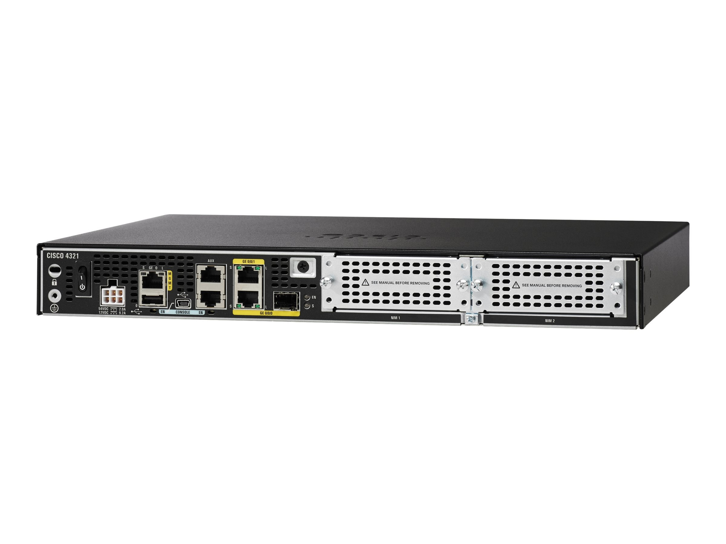



By, Liam Gilmartin.

**Purpose** – The purpose of this lab is to learn how to use VRF over 3 routers and 2 PC’s. Also, to divide the network in half, one side being Microsoft and the other being Google and figuring out how to allow them to communicate.

**Background Information on Lab Concepts** - VRF increases connectivity by enabling network paths to be segmented while not using multiple devices. Since traffic is automatically segregated, VRF also increases network security which eliminates any need for encryption and/or authentication.

**Lab Summary** - There were 3 routers and 2 PCs used in this lab as far as hardware goes. And as far as software there were 2 loopbacks used. What we actually did was, we connected three routers to two PCs and configured a loopback on each router. In our configuration the two PCs were not connected but could talk. The loopbacks were set up and connected the same way, they were not connected and couldn’t talk. Every router on the network was physically connected to each other.

**Lab Commands** -

ip vrf Microsoft

Ip vrf forwarding Google

Ip vrf google

Ip vrf forwarding Microsoft

router ospf # vrf Google

**Network Diagram with IP’s** -

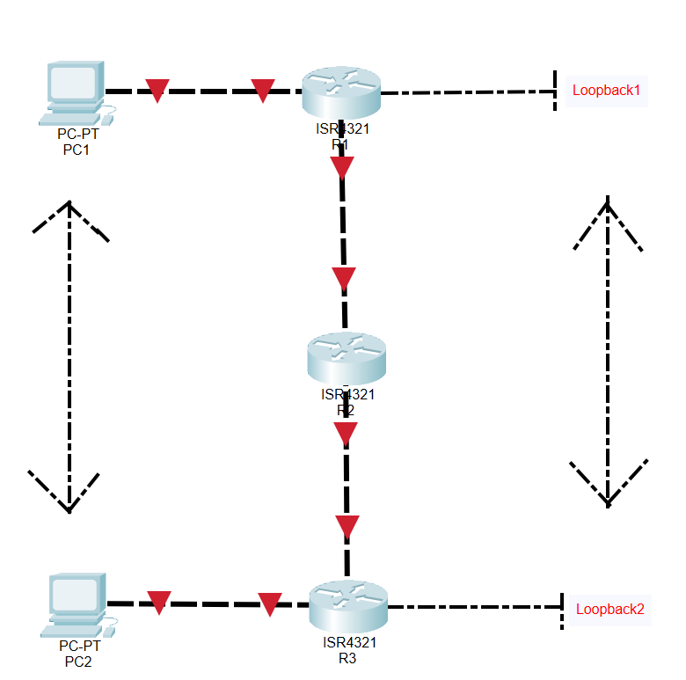

**Configurations** -

hostname R1

boot-start-marker

boot-end-marker

vrf definition Mgmt-intf

address-family ipv4

exit-address-family

address-family ipv6

exit-address-family

no aaa new-model

ip vrf Google

ip vrf Microsoft

subscriber templating

vtp domain cisco

vtp mode transparent

multilink bundle-name authenticated

license udi pid ISR4321/K9 sn FDO214421CF

spanning-tree extend system-id

redundancy

mode none

vlan internal allocation policy ascending

vlan 10,20

interface Loopback0

ip vrf forwarding Microsoft

ip address 192.168.1.1 255.255.255.0

interface GigabitEthernet0/0/0

no ip address

negotiation auto

interface GigabitEthernet0/0/0.10

encapsulation dot1Q 1 native

ip vrf forwarding Google

ip address 192.168.2.1 255.255.255.0

interface GigabitEthernet0/0/0.20

encapsulation dot1Q 2

ip vrf forwarding Microsoft

ip address 192.168.2.2 255.255.255.0

interface GigabitEthernet0/0/1

ip vrf forwarding Google

ip address 192.168.1.2 255.255.255.0

negotiation auto

interface Serial0/1/0

no ip address

interface Serial0/1/1

no ip address

interface GigabitEthernet0

vrf forwarding Mgmt-intf

no ip address

negotiation auto

interface Vlan1

no ip address

router ospf 1

router-id 1.1.1.1

network 192.168.1.0 0.0.0.255 area 0

network 192.168.2.0 0.0.0.255 area 0

router ospf 2 vrf Google

network 192.168.1.0 0.0.0.255 area 0

network 192.168.2.0 0.0.0.255 area 0

router ospf 3 vrf Microsoft

network 192.168.1.0 0.0.0.255 area 0

network 192.168.2.0 0.0.0.255 area 0

ip forward-protocol nd

no ip http server

no ip http secure-server

ip tftp source-interface GigabitEthernet0

control-plane

line con 0

stopbits 1

line aux 0

stopbits 1

line vty 0 4

login

End

hostname R2

boot-start-marker

boot-end-marker

vrf definition Mgmt-intf

address-family ipv4

exit-address-family

address-family ipv6

exit-address-family

no aaa new-model

ip vrf Google

ip vrf Microsoft

subscriber templating

multilink bundle-name authenticated

license udi pid ISR4321/K9 sn FDO211216BL

spanning-tree extend system-id

redundancy

mode none

vlan internal allocation policy ascending

interface GigabitEthernet0/0/0

no ip address

negotiation auto

interface GigabitEthernet0/0/0.10

encapsulation dot1Q 1 native

ip vrf forwarding Google

ip address 192.168.5.1 255.255.255.0

interface GigabitEthernet0/0/0.20

encapsulation dot1Q 2

ip vrf forwarding Microsoft

ip address 192.168.5.2 255.255.255.0

interface GigabitEthernet0/0/1

no ip address

negotiation auto

interface GigabitEthernet0/0/1.10

encapsulation dot1Q 1 native

ip vrf forwarding Google

ip address 192.168.2.3 255.255.255.0

interface GigabitEthernet0/0/1.20

encapsulation dot1Q 2

ip vrf forwarding Microsoft

ip address 192.168.2.4 255.255.255.0

interface Serial0/1/0

no ip address

interface Serial0/1/1

no ip address

interface GigabitEthernet0

vrf forwarding Mgmt-intf

no ip address

negotiation auto

interface Vlan1

no ip address

router ospf 1 vrf Google

network 192.168.2.0 0.0.0.255 area 0

network 192.168.5.0 0.0.0.255 area 0

router ospf 2

router-id 2.2.2.2

network 192.168.2.0 0.0.0.255 area 0

network 192.168.5.0 0.0.0.255 area 0

router ospf 3 vrf Microsoft

network 192.168.2.0 0.0.0.255 area 0

network 192.168.5.0 0.0.0.255 area 0

ip forward-protocol nd

no ip http server

no ip http secure-server

ip tftp source-interface GigabitEthernet0

control-plane

line con 0

stopbits 1

line aux 0

stopbits 1

line vty 0 4

login

End

hostname R3

boot-start-marker

boot-end-marker

vrf definition Mgmt-intf

address-family ipv4

exit-address-family

address-family ipv6

exit-address-family

no aaa new-model

ip vrf Google

ip vrf Microsoft

subscriber templating

vtp domain cisco

vtp mode transparent

multilink bundle-name authenticated

license udi pid ISR4321/K9 sn FDO214420G7

spanning-tree extend system-id

redundancy

mode none

vlan internal allocation policy ascending

vlan 10,20

interface Loopback0

ip vrf forwarding Microsoft

ip address 192.168.10.1 255.255.255.0

interface GigabitEthernet0/0/0

ip vrf forwarding Google

ip address 192.168.10.2 255.255.255.0

negotiation auto

interface GigabitEthernet0/0/1

no ip address

negotiation auto

interface GigabitEthernet0/0/0.1

encapsulation dot1Q 10 native

ip vrf forwarding Google

ip address 192.168.5.1 255.255.255.0

interface GigabitEthernet0/0/0.2

encapsulation dot1Q 20

ip vrf forwarding Microsoft

ip address 192.168.5.2 255.255.255.0

interface Serial0/1/0

no ip address

shutdown

interface Serial0/1/1

no ip address

shutdown

interface GigabitEthernet0

vrf forwarding Mgmt-intf

no ip address

shutdown

negotiation auto

interface Vlan1

no ip address

shutdown

router ospf 1 vrf Google

network 192.168.5.0 0.0.0.255 area 0

network 192.168.10.0 0.0.0.255 area 0

router ospf 2 vrf Microsoft

network 192.168.5.0 0.0.0.255 area 0

network 192.168.10.0 0.0.0.255 area 0

router ospf 3

router-id 3.3.3.3

network 192.168.5.0 0.0.0.255 area 0

network 192.168.10.0 0.0.0.255 area 0

ip forward-protocol nd

no ip http server

no ip http secure-server

ip tftp source-interface GigabitEthernet0

control-plane

line con 0

stopbits 1

line aux 0

stopbits 1

line vty 0 4

login

end

**Problems** - Problems with this lab were mainly the IP scheme which was of course the last thing we checked when we were troubleshooting. First, I thought it would be something to do with the VRF commands within the lab. Then when we found out it could not be that we began scouring our configurations to try to find the error, however we could not find one. This is when we tried to rewrite the IP scheme and found that was the only issue we had left to fix.

**Conclusion** - In closing this lab was overall was the hardest lab we have done so far this year. Mainly because the lab had so many minute details included that it took us quite a while to figure out the issues and then complete it. What I learned was that in a detailed lab like this one there can be very many small problems that are overlooked. I also learned that to figure out problems like this you must dig deeper into the lab and check every single little detail and not just the ones that you think are important.